Iron Hypothesis

“Give me a half tanker of iron, and I will give you an ice age.”- John Martin.(Coale et al., 2016)
As the climate is degrading gradually, at some point we all probably thought that what if we could bring back the ice age, then all the environmental parameter would be in their normal state. Which is theoretically possible as know that earth have faced 5 ice age previews and another one is coming. (Ice Age - Definition & Timeline | HISTORY, n.d.)
What if we could bring it much faster? Wouldn’t that be great? Or possible?
John Martin
That’s when Iron Hypothesis come to enlighten us. As we know that phytoplankton acts as a biological carbon pump(Wang et al., 2023). Phytoplankton absorbs the carbon di oxide during their photosynthesis and after their death some of the carbon di oxide sinks down the ocean basin reducing co₂ from the atmosphere.
And if this process keeps on for a long time at a very large scale, this would decrease the amount of co2 in the atmosphere. And thus, it will lower the temperature of the Earth rapidly. And if we could keep this up for long time at very large scale, this could ultimately trigger the ice age formation.
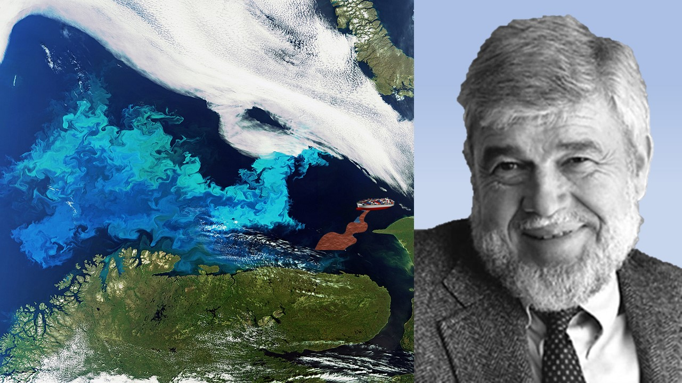
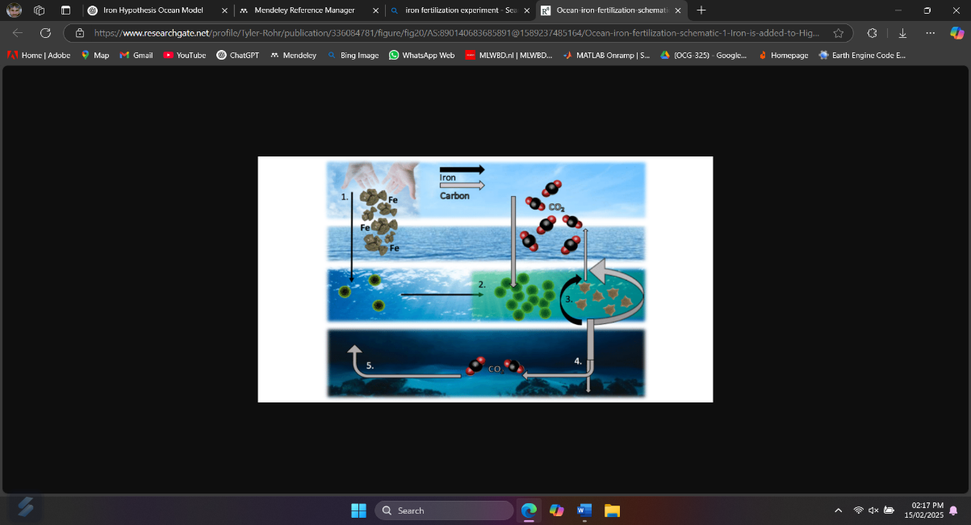
In the ocean there are many High Nutrient Low Chlorophyll (HNLC) zone. In those regions, adding a little bit of iron could enhance the growth of phytoplankton and could lead to phytoplankton bloom.
Algal Bloom
In 1993, scientist tested his theory in the field. They fertilized iron in HNLC zone of the ocean. Which caused algal bloom. (30 Years: The Iron Hypothesis Is No More – Moss Landing Marine Laboratories, n.d.)
From that experiment it was proved that iron acts as limiting nutrient for phytoplankton growth. And Iron hypothesis was right not a crazy idea of any mad scientist.

Many scientists of his era called this idea as “ill founded” theory, or “Geritol” (supplement) for the environment. And people even called him as “Johnny Iron seed” or “Iron Man”.(John Martin, 2001)
Later the NSF considered this work as one of the top discoveries in oceanography in the past 100 years. (30 Years: The Iron Hypothesis Is No More – Moss Landing Marine Laboratories, n.d.)

Reference:
30 years: The iron hypothesis is no more – Moss Landing Marine Laboratories. (n.d.). Retrieved February 15, 2025, from https://mlml.sjsu.edu/2020/06/18/30-years-the-iron-hypothesis-is-no-more/
Coale, K., Bitondo, A., Christensen, S., Drake, C., Fennie, W., Loiacono, S., Navas, G., Rhett, G., Walovich, K., Woods, A., & Worden, S. (2016). John Holland Martin: From Picograms to Petagrams and Copepods to Climate: The Class of MS 280, Moss Landing Marine Laboratories. Limnology and Oceanography Bulletin, 25(2), 36–46. https://doi.org/10.1002/lob.10078
Ice Age - Definition & Timeline | HISTORY. (n.d.). Retrieved February 15, 2025, from https://www.history.com/topics/pre-history/ice-age
John Martin. (2001).
Wang, W.-L., Fu, W., Le Moigne, F. A. C., Letscher, R. T., Liu, Y., Tang, J.-M., & Primeau, F. W. (2023). Biological carbon pump estimate based on multidecadal hydrographic data. Nature, 624(7992), 579–585. https://doi.org/10.1038/s41586-023-06772-4

